cat command for word file
cat command for document file will display everything.

man command ($ man ls)
it displays all the possible things could be done with ls command here.

ls --l
displays the help of ls.

mkdir command
this command isused to create the directory.

folder sujana is created using mkdir command

rmdir command
this command is used to remove the directory.

who command
it shows the current user.

date command
displays the date.

cal command
displays the calendar

cd Desktop/Demo command

touch command
to create a file we use this command.

z folder is created by using touch command

rm command
folder name with z will be removed

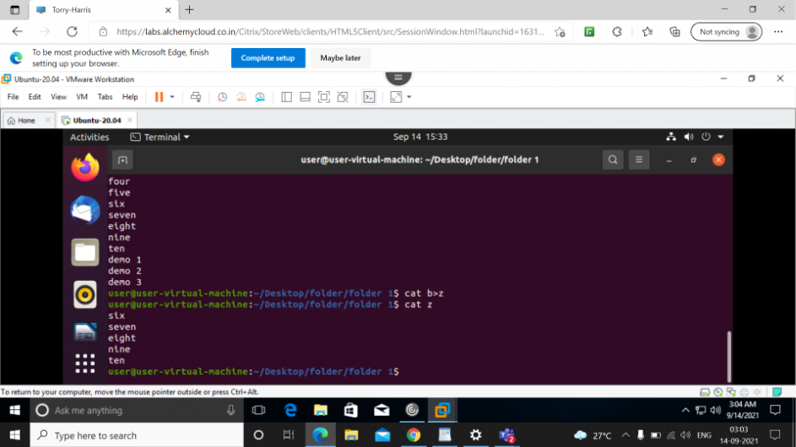

cat b>z
copies everything in 'b' to 'z'.

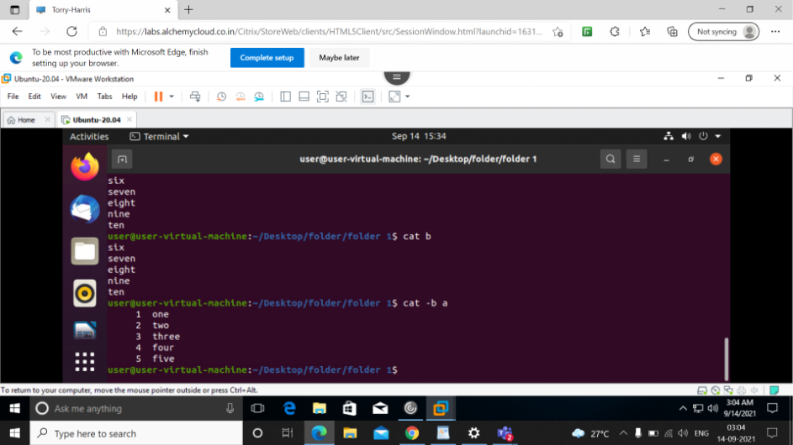
cat -b a
cat -b is used to display in line numbers ,here all the data in file 'a' is displayed with numbers.

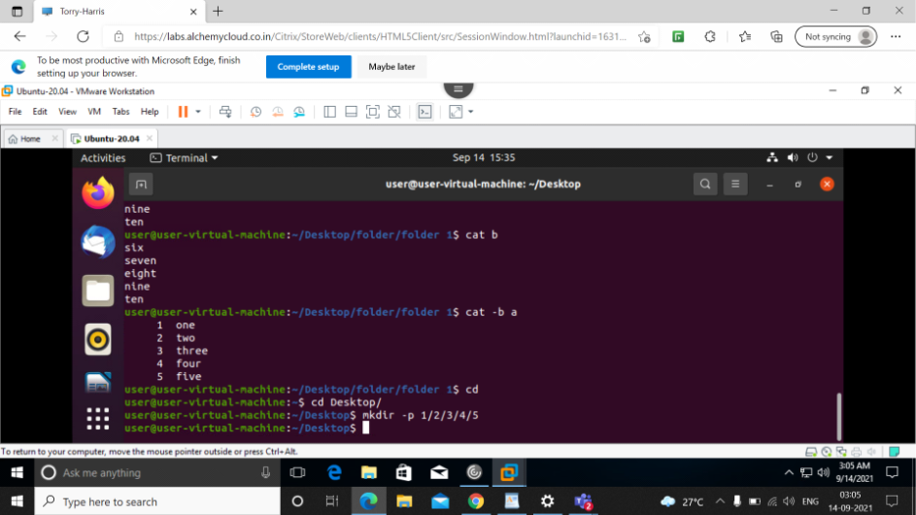
mkdir -p 1/2/3/4/5
this command is used to create a folders inside a folder.

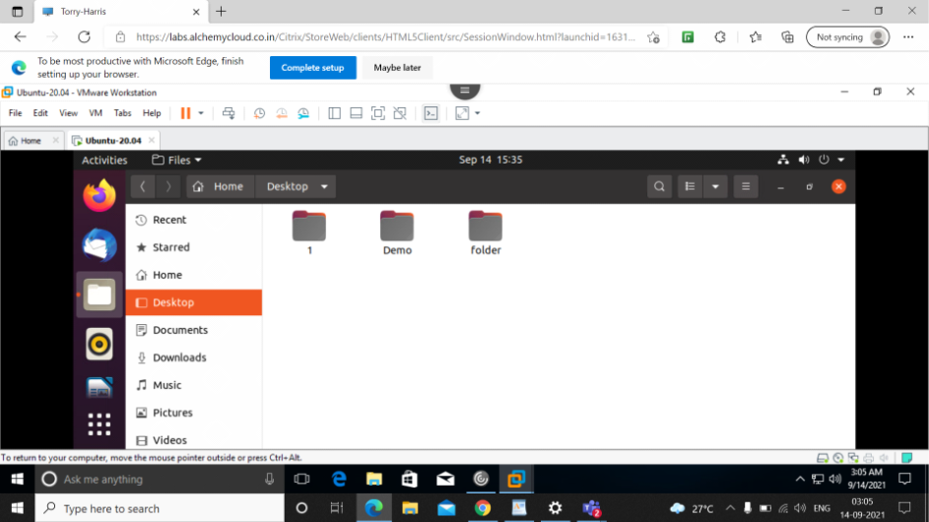
now here folder 1 is created inside which has folders (folder 1 to folder 5)

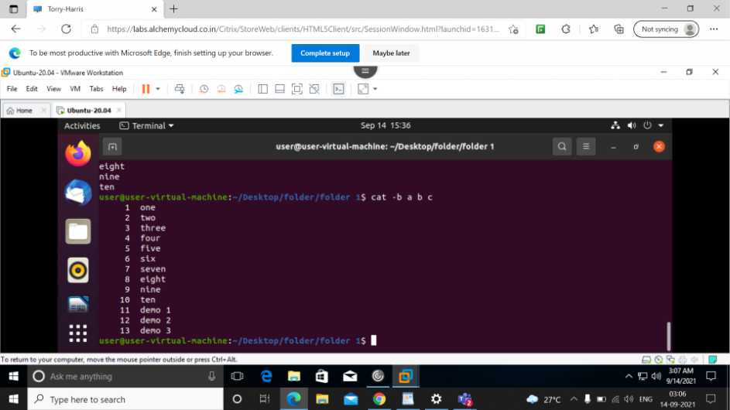

cat -b
displays all the data from the file 'a','b','c'

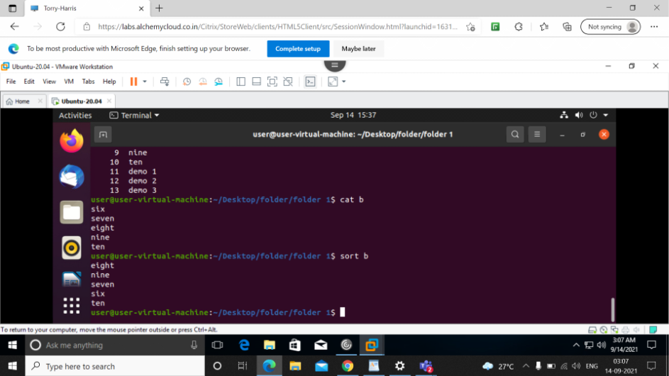
sort command
displays the data in dictionary order.

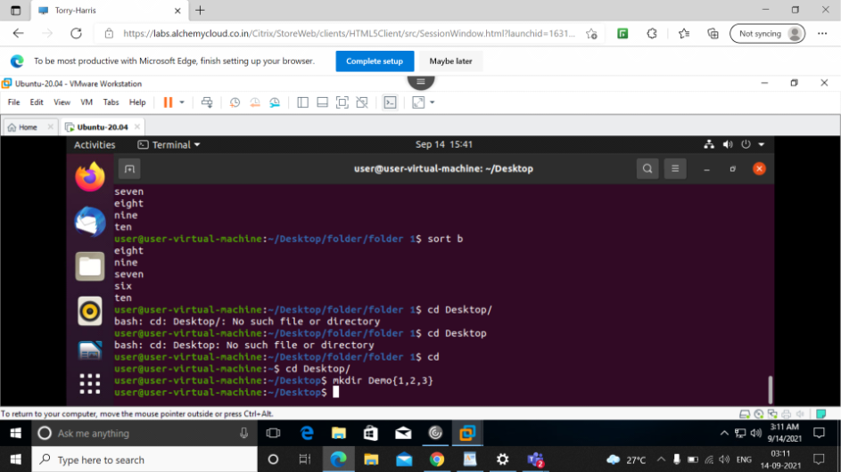

mkdir Demo{1,2,3}
this command is used to create multiple folders like Demo1,Demo2,and Demo3.

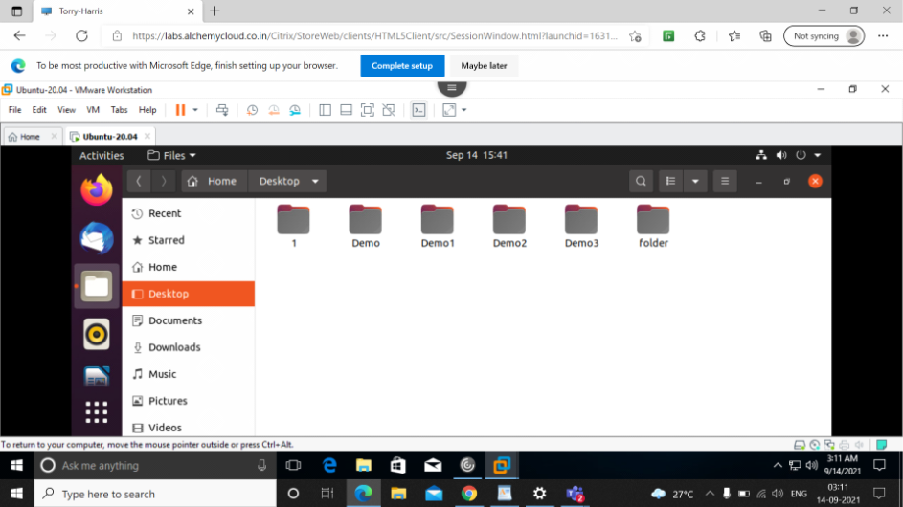
this is how it is created.

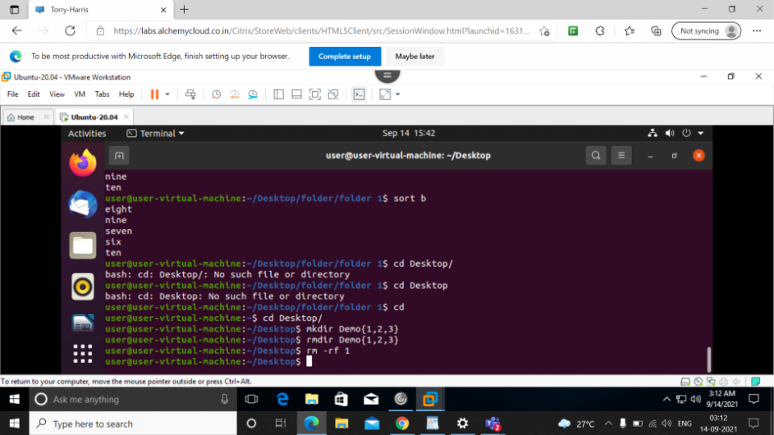

rmdir Demo{1,2,3}
this command will delete the created Demo folders.
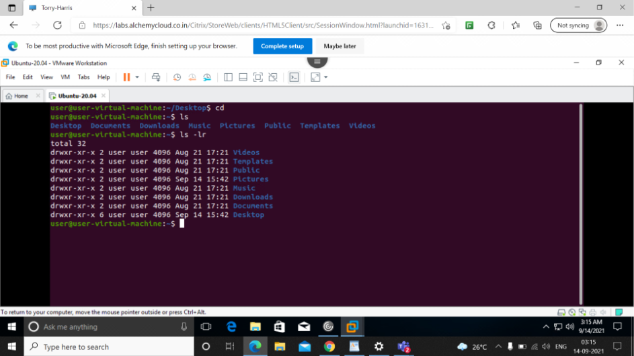
ls –lr command
data will be displayed in reverse order.
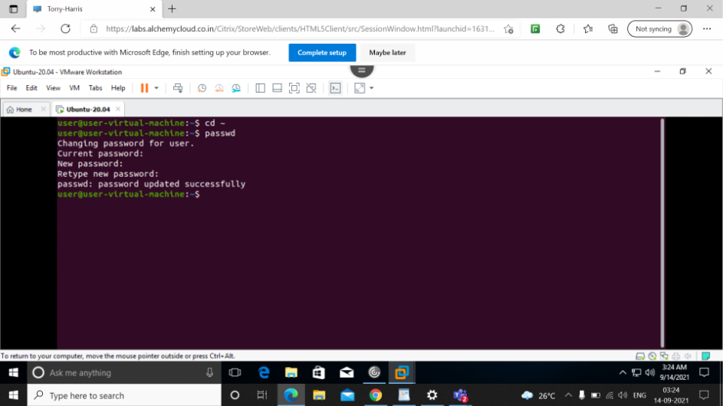
passwd command
this command is used to create new passwd

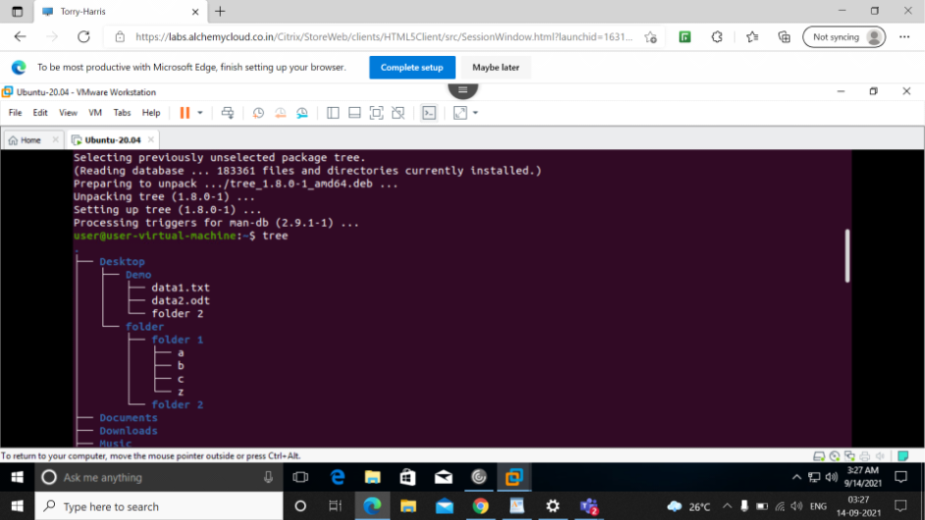

tree command
displays the directories in a hierarchical way.
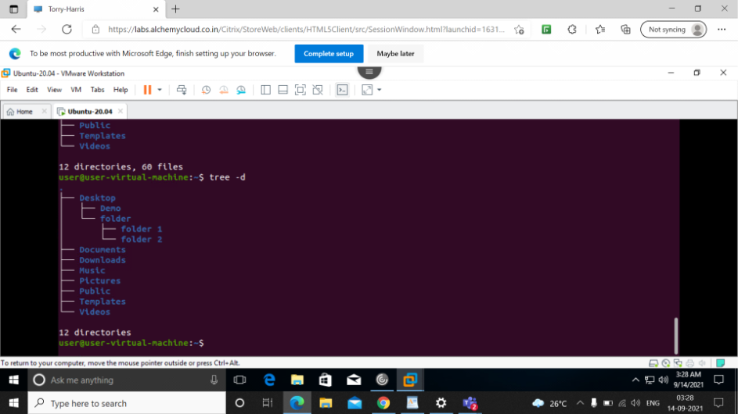
tree -d
displays directories that are present in desktop.
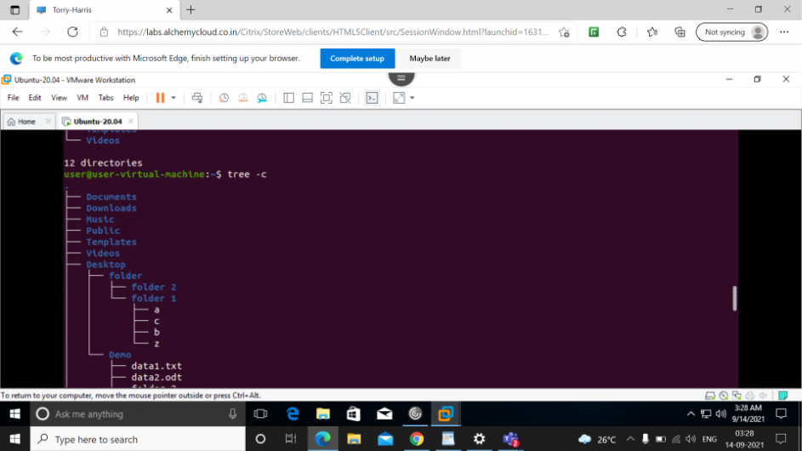
tree -c
displays all the directory ,files and documents.
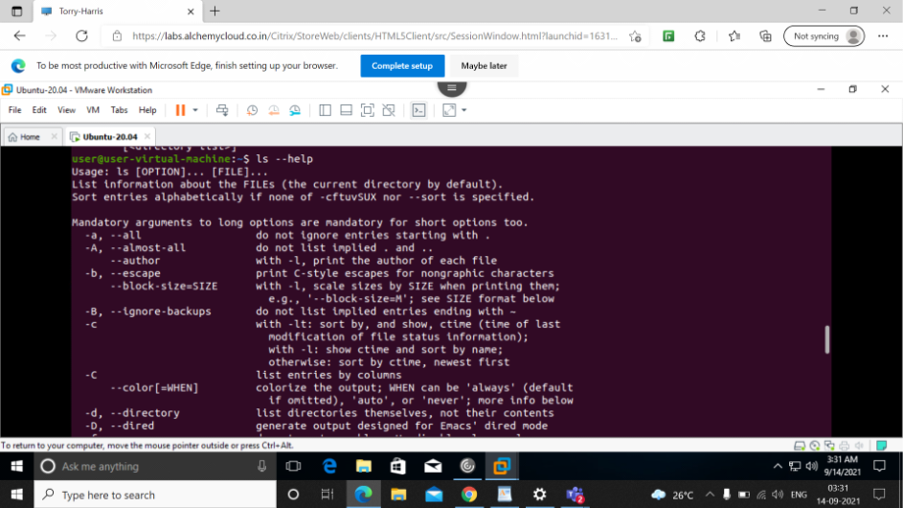
ls --help
helps with need of any command.gives the information of the command.



